ภาคผนวก ก
การติดตั้งโปรแกรม WIN-PROLOG

ขั้นตอนการติดตั้ง โปรแกรม LPA WIN-PROLOG
1. เมื่อใส่แผ่นโปรแกรมเข้าไปแล้วโปรแกรมการติดตั้งจะถูกโหลดขึ้นมาโดยอัตโนมัติ ดังรูป

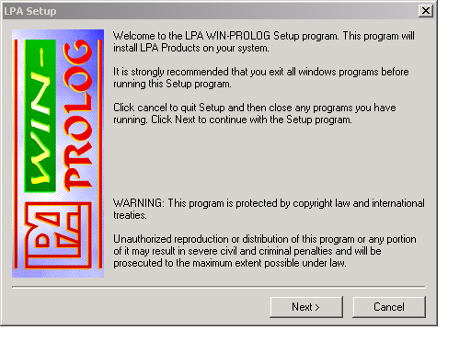
รูปที่ 1 แสดงหน้าแรกของการติดตั้ง

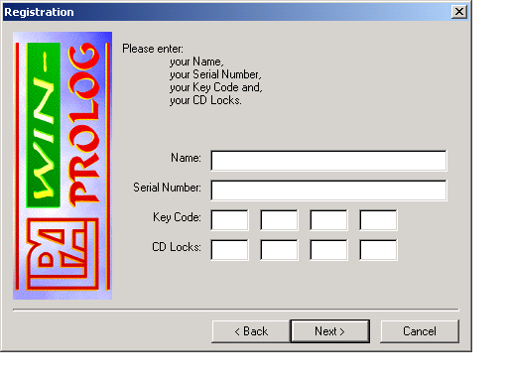
รูปที่ 2 กรอกข้อมูลให้ครบถ้วน
2. เมื่อกด Next แล้ว จะมายังหน้าถัดไป ซึ่งในส่วนนี้โปรแกรมจะให้เรากรอกข้อมูลต่าง ซึ่งต้องกรอกให้ถูกต้องจึงจะสามารถผ่านไปหน้าถัดไปได้ ดังรูปที่ 2

3 สำหรับหน้านี้จะให้เราเลือกทูลคิทที่จะใช้งาน โดยส่วนที่จะใช้งานให้เลือกทั้งหมด ดังรูปที่ 3

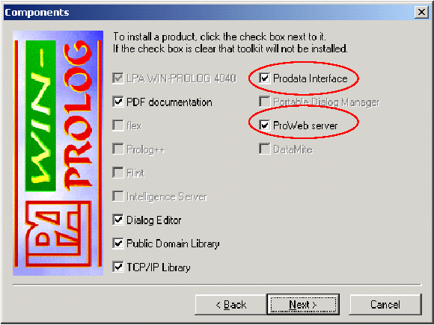
รูปที่ 3 เลือกทูลคิท

4. เมื่อกด Next แล้วโปรแกรมจะให้เราเลือกไดเร็กทอรี่ที่จะติดตั้ง ดังรูปที่ 4 เมื่อเลือกเรียบร้อยแล้วกด Next โปรแกรมก็จะถูกติดตั้งให้เป็นอันเรียบร้อย
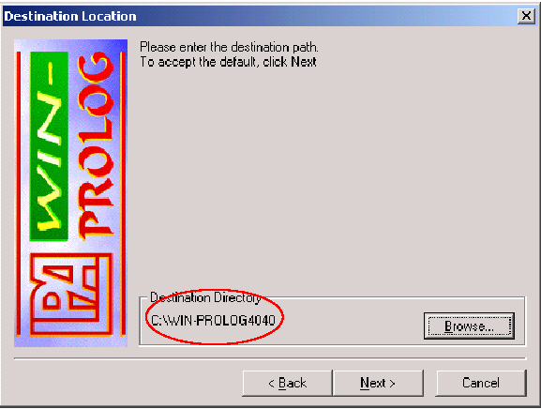
รูปที่ 4 เลือกไดเร็กทอรี่ที่จะติดตั้งโปรแกรม

5. หน้าตาของโปรแกรม WIN-PROLOG ดังรูปที่ 5

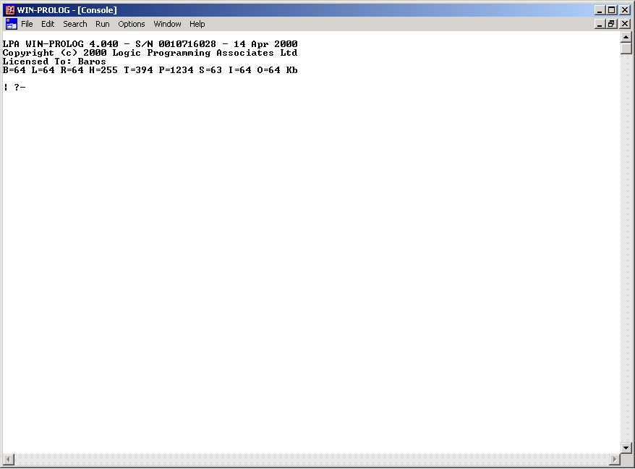
รูปที่ 5 หน้าตาของโปรแกรม

6. การคอมไพล์โปรแกรมที่เขียนโดยภาษาโปรล็อกโดยใช้ WIN-PROLOG ให้เลือกที่ Run -> Comile

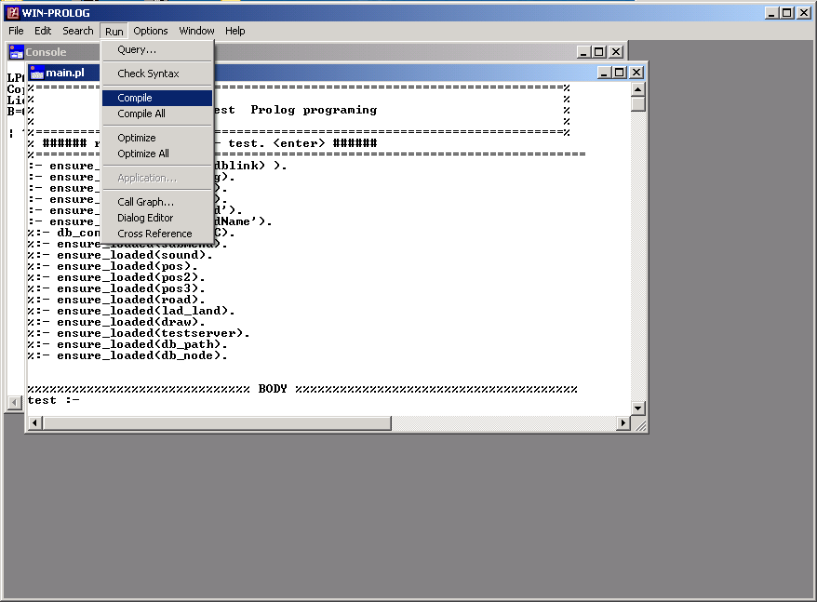
รูปที่ 6 แสดงการคอมไพล์โปรแกรม
ภาคผนวก ข
โค้ดโปรแกรม

1. ส่วนโปรแกรมหลัก(main.pl)
:- ensure_loaded( system(dblink) ).
:- ensure_loaded(subdialog).
:- ensure_loaded(testfile).
:- ensure_loaded('server').
:- ensure_loaded('findRoad').
:- ensure_loaded('findRoadName').
:- ensure_loaded('findLogCar').
:- ensure_loaded('searchPath').

%%%%%%%%%%%%%%%%% ส่วนสร้างหน้าต่างหลัก %%%%%%%%%%%%%%%%%%
map :-
tidy_fred,
init_fred,
_S1 = [ws_sysmenu,ws_popup,ws_caption,dlg_ownedbyprolog],
_S2 = [ws_child,bs_groupbox,ws_visible,ws_group],
_S3 = [ws_child,ws_visible,ws_group,ws_tabstop,bs_ownerdraw],
_S4 = [ws_child,ws_visible,ws_group,ws_tabstop],
_S5 = [ws_child,ws_visible,ws_tabstop,ws_border,es_left,es_multiline,es_autohscroll, es_autovscroll,es_readonly],
Dstyle1 = [dlg_ownedbyprolog,ws_sysmenu,ws_thickframe,ws_caption],
Bstyle = [ws_child,ws_visible,ws_tabstop,bs_pushbutton],
Sstyle = [ws_child,ws_visible,ws_group],
Gstyle = [ws_child,ws_visible,ws_border],%,ws_hscroll,ws_vscroll],

wdcreate( fred , `Gps Tracking` ,0 , 0, 900, 700, Dstyle1 ),
wccreate( (fred,9000), grafix, `Map` ,10, 70, 870, 550,Gstyle ),
wccreate( (fred,9001), grafix, `Car` ,10, 70, 870, 550,Gstyle ),
wccreate( (fred,9002), grafix, `Road Find` ,10, 70, 870, 550,Gstyle ),
wccreate( (fred,91), grafix, `` ,10, 70, 870, 550,Gstyle ),
wccreate( (fred,11000), static, `Latitude :~I0~MLongitude:~I0`,10 , 630, 200, 25, Sstyle ),
wccreate( (fred,11003), static, `Road :` ,10 , 655, 200, 25, Sstyle ),
wccreate( (fred,11001), button, `` ,10 , 10 , 875, 50, _S2 ),
wccreate( (fred,11002), static, `00:00:00` ,820, 650, 100, 25, Sstyle ),
wccreate( (fred,1000), button, `Tracking` ,15 , 17, 70, 40, _S3 ),
wccreate( (fred,1001), button, `Pan` ,190, 17, 50, 40, _S3 ),
wccreate( (fred,1002), button, `Zoom` ,240, 17, 50, 40, _S3 ),
wccreate( (fred,1003), button, `Layer` ,290, 17, 50, 40, _S3 ),
wccreate( (fred,1004), button, `&Car` ,440, 17, 50, 40, _S4 ),
wccreate( (fred,1006), button, `Stop` ,745, 17, 40, 40, _S3 ),
wccreate( (fred,1007), button, `play` ,390, 17, 50, 40, _S3 ),
wccreate( (fred,1008), button, `Arrow` ,140, 17, 50, 40, _S4 ),
wccreate( (fred,1009), button, `Road` ,340, 17, 50, 40, _S3 ),

dialog_layer,
assert( temp_size(0) ),
assert( temp_zoom(0) ), %zoom =0(click arrow button),zoom =1(click zoom buton)
assert( temp_zoominout(1) ), %zoom in=1 zoom out =2
assert( temp_pan(0) ),
assert( left_click(0,0)),
assert( temp_origin(10,10) ),
assert( check_click(0)),
assert( layersize(1001,747) ), %(32349,25832)
assert( temp_carpoint(0,0)),

timer( 1, 1000 ),
wfont( (fred,11002), 0 ),
winsize( W0, H0 ),
window_handler(fred,fred_handler),
call_dialog(fred,_),
tidy_fred.
tidy_fred :-
abolish( temp_select/1 ),
abolish( temp_setroad/1), %check for set map origin for drawroad 0=not set 1 = set
abolish( temp_gfx/3 ),
abolish( temp_gfx7/3 ),
abolish( temp_size/1 ),
abolish( temp_zoom/1 ), %check zoom or not
abolish( temp_zoominout/1), %check zoom in or zoom out
abolish( temp_pan/1 ),
abolish( check_click/1 ), %check left click (pan mode)
abolish( left_click/2 ), %store left button click at the map
abolish( temp_origin/2 ), %store origin of map after leftup
abolish( layersize/2 ),
abolish( temp_carpoint/2),

catch( _, gfx_metafile_close(map) ),
catch( _, gfx_metafile_close(map_police) ),
catch( _, gfx_metafile_close(map_post) ),
catch( _, gfx_metafile_close(map_hospital) ),
catch( _, gfx_metafile_close(map_bank) ),
catch( _, gfx_metafile_close(map_station) ),
catch( _, gfx_metafile_close(map_soi) ),
catch( _, gfx_metafile_close(car) ),

catch( _, gfx_bitmap_close(bExitUp) ),
catch( _, gfx_bitmap_close(bExitDown) ),
catch( _, gfx_bitmap_close(bZoomUp) ),
catch( _, gfx_bitmap_close(bZoomDown) ),
catch( _, gfx_bitmap_close(bArrowUp) ),
catch( _, gfx_bitmap_close(bArrowDown) ),
catch( _, gfx_bitmap_close(bRoadUp) ),
catch( _, gfx_bitmap_close(bRoadDown) ),
catch( _, gfx_bitmap_close(bTrackingUp) ),
catch( _, gfx_bitmap_close(bTrackingDown) ),
catch( _, gfx_bitmap_close(bPlayBackUp) ),
catch( _, gfx_bitmap_close(bPlayBackDown) ),
catch( _, gfx_font_close(big) ),
catch( _, gfx_pen_close( red3) ),
catch( _, gfx_pen_close( red) ),
catch( _, gfx_pen_close( red31) ),
catch( _, gfx_brush_close( white ) ),
catch( _, gfx_brush_close( red ) ),
catch( _, wclose(fred) ),
catch( _, wclose(dgLayer) ),
!.

% initialise dynamic data and graphics objects
init_fred :-
dynamic( temp_select/1 ),
dynamic( temp_setroad/1),
dynamic( temp_gfx/3 ),
dynamic( temp_gfx7/3 ),
dynamic( temp_size/1),
dynamic( temp_zoom/1),
dynamic( temp_zoominout/1),
dynamic( temp_pan/1),
dynamic( check_click/1),
dynamic( left_click/2),
dynamic( temp_origin/2),
dynamic( layersize/2 ),
dynamic( temp_carpoint/2),

gfx_metafile_load( map, 'D:\tracking\map\roadsoi.wmf'),%newroad.wmf' ),
gfx_metafile_load( map_police, 'D:\tracking\map\police.wmf' ),
gfx_metafile_load( map_post, 'D:\tracking\map\post.wmf' ),
gfx_metafile_load( map_hospital, 'D:\tracking\map\hostpital.wmf' ),
gfx_metafile_load( map_bank, 'D:\tracking\map\bank.wmf' ),
gfx_metafile_load( map_station, 'D:\tracking\map\station.wmf' ),
gfx_metafile_load( map_soi, 'D:\tracking\map\soi.wmf' ),
gfx_metafile_load( car, 'D:\tracking\map\car2.wmf'),
gfx_bitmap_load( bExitUp, 'D:\tracking\bmp\stop_up.bmp'),
gfx_bitmap_load( bExitDown, 'D:\tracking\bmp\stop_down.bmp'),
gfx_bitmap_load( bZoomUp, 'D:\tracking\bmp\zoom_up.bmp'),
gfx_bitmap_load( bZoomDown, 'D:\tracking\bmp\zoom_down.bmp'),
gfx_bitmap_load( bPanUp, 'D:\tracking\bmp\pan_up.bmp'),
gfx_bitmap_load( bPanDown, 'D:\tracking\bmp\pan_down.bmp'),
gfx_bitmap_load( bLayerUp, 'D:\tracking\bmp\layer_up.bmp'),
gfx_bitmap_load( bLayerDown, 'D:\tracking\bmp\layer_down.bmp'),
gfx_bitmap_load( bHistoryUp, 'D:\tracking\bmp\info_up.bmp'),
gfx_bitmap_load( bHistoryDown, 'D:\tracking\bmp\info_down.bmp'),
gfx_bitmap_load( bRoadUp, 'D:\tracking\bmp\road_up.bmp'),
gfx_bitmap_load( bRoadDown, 'D:\tracking\bmp\road_down.bmp'),
gfx_bitmap_load( bTrackingUp, 'D:\tracking\bmp\trackingup.bmp'),
gfx_bitmap_load( bTrackingDown, 'D:\tracking\bmp\trackingdown.bmp'),
gfx_bitmap_load( bArrowUp, 'D:\tracking\bmp\arrowup.bmp'),
gfx_bitmap_load( bArrowDown, 'D:\tracking\bmp\arrowdown.bmp'),
gfx_bitmap_load( bPlayBackUp, 'D:\tracking\bmp\playbackup.bmp'),
gfx_bitmap_load( bPlayBackDown, 'D:\tracking\bmp\playbackdown.bmp'),

gfx_font_create(big,'angsanaUPC',24,bolditalic),
gfx_pen_create( red3,255, 0,125, 3 ),
gfx_pen_create( red, 120, 29,255, 2 ),
gfx_pen_create( red31,255, 0,125, 5 ),
gfx_brush_create( red, 255, 0, 0, solid ),
gfx_brush_create( white, 255, 255, 255, solid ),
!.

%========= Press on Exit Button ================
fred_handler((fred,1006),msg_paint,button_up,_):-
gfx_paint( (fred,1006) ),
gfx( bitmap(0,0,50,40,0,0,bExitUp) ),
gfx_end( (fred,1006) ).

fred_handler((fred,1006),msg_paint,button_down,_):-
gfx_paint( (fred,1006) ),
gfx( bitmap(0,0,50,40,0,0,bExitDown) ),
gfx_end( (fred,1006) ).

fred_handler((fred,1006),msg_button,_,done).

%================ Message on Grafix ======================
% Mouse Move
fred_handler((fred,9000), msg_mousemove, (X,Y),_) :-
%nameOfRoad(X,Y),
chang_xyTolalong(X,Y,Lat,Long),
findNameofRoad(Lat,Long,Name),
( write(` Road :~I`),
write(Name) )~>New2,
wtext((fred,11003),New2),
number_string(Lat,Xstring),
number_string(Long,Ystring),
( write(` Latitude :~I`),
write(Xstring),
write(`~M Longitude :~I`),
write(Ystring) ) ~> New,
wtext((fred,11000),New),

% ===== left click and move map =======
check_click(Click),
( Click = 1 -> (
Zoom = 0
->(
temp_origin( X0,Y0 ),
left_click(Xleftclick,Yleftclick),
gfx_begin( (fred,9000) ),
gfx_transform(X1,Y1,X,Y),
Xnew is ( (Xleftclick - X1)+X0 ),
Ynew is ( (Yleftclick - Y1)+Y0 ),
draw_paper,
gfx_end( (fred,9000) ),
retract( temp_origin(Xtmp,Ytmp) ),
assert( temp_origin(Xnew,Ynew) ),
retract( left_click( T1,T2 ) ),
assert( left_click( X1,Y1 ) )
);!
);!
).
%====================== Mouse left button up ========================
fred_handler((fred,9000), msg_leftup, (X,Y),_) :-
retract( check_click(Click) ),
assert( check_click(0) ),
gfx_begin( (fred,9000) ),
draw_paper,
gfx_end( (fred,9000) ).

%====================== Tracking Server =============================
fred_handler((fred,1000),msg_paint,button_up,_):-
gfx_paint( (fred,1000) ),
gfx( bitmap(0,0,120,40,0,0,bTrackingUp) ),
gfx_end( (fred,1000) ).
fred_handler((fred,1000),msg_paint,button_down,_):-
gfx_paint( (fred,1000) ),
gfx( bitmap(0,0,120,40,0,0,bTrackingDown) ),
gfx_end( (fred,1000) ).

fred_handler((fred,1000),msg_button,_,_):-
start.

%====================== Arrow Button Handle =========================
fred_handler((fred,1008),msg_paint,button_up,_):-
gfx_paint( (fred,1008) ),
gfx( bitmap(0,0,50,40,0,0,bArrowUp) ),
gfx_end( (fred,1008) ).

fred_handler((fred,1008),msg_paint,button_down,_):-
gfx_paint( (fred,1008) ),
gfx( bitmap(0,0,50,40,0,0,bArrowDown) ),
gfx_end( (fred,1008) ).

fred_handler((fred,1008),msg_button,_,_):-
gfx_begin( (fred,9000) ),
gfx_window_cursor( (fred,9000), stock(arrow_cursor) ),
gfx_end( (fred,9000) ),
retract( temp_zoom(Zoom)),
assert( temp_zoom(0)),
retract( temp_pan(Pan) ),
assert( temp_pan(0) ).

%====================== Pan Button Handle =========================
fred_handler((fred,1001),msg_paint,button_up,_):-
gfx_paint( (fred,1001) ),
gfx( bitmap(0,0,50,40,0,0,bPanUp) ),
gfx_end( (fred,1001) ).

fred_handler((fred,1001),msg_paint,button_down,_):-
gfx_paint( (fred,1001) ),
gfx( bitmap(0,0,50,40,0,0,bPanDown) ),
gfx_end( (fred,1001) ).

fred_handler((fred,1001),msg_button,_,_):-
gfx_begin( (fred,9000) ),
gfx_window_cursor( (fred,9000), stock(size_cursor) ),
gfx_end( (fred,9000) ),
retract( temp_zoom(Zoom)),
assert( temp_zoom(0)),
retract( temp_pan(Pan) ),
assert( temp_pan(1) ).

%======================== Zoom Button Handler ===================
fred_handler((fred,1002),msg_paint,button_up,_):-
gfx_paint( (fred,1002) ),
gfx( bitmap(0,0,50,40,0,0,bZoomUp) ),
gfx_end( (fred,1002) ).

fred_handler((fred,1002),msg_paint,button_down,_):-
gfx_paint( (fred,1002) ),
gfx( bitmap(0,0,50,40,0,0,bZoomDown) ),
gfx_end( (fred,1002) ).

fred_handler((fred,1002),msg_button,_,_):-
gfx_begin( (fred,9000) ),
gfx_window_cursor( (fred,9000), stock(icon_cursor) ),
gfx_end( (fred,9000) ),
retract( temp_zoom(Zoom)),
assert(temp_zoom(1)),
retract( temp_pan(Pan) ),
assert( temp_pan(0) ).

%%% Zoom in %%%
fred_handler((fred,9000), msg_leftdown, (X,Y),_) :-
temp_zoom(Zoom),
temp_pan(Pan),
( Zoom = 1 -> zoom_in(X,Y),
gfx_begin( (fred,9000) ),
draw_paper,
gfx_end( (fred,9000) )

%else click pan button
; ( Pan = 1 -> retract( left_click(Xleftclick,Yleftclick) ),
gfx_begin( (fred,9000) ),
gfx_window_cursor( (fred,9000), stock(size_cursor) ),
gfx_transform(X1,Y1,X,Y),
gfx_end( (fred,9000) ),
assert( left_click(X1,Y1) ),
retract( check_click(Click) ),
assert( check_click(1) ),!
; !
)).
%%% Zoom out %%%
fred_handler((fred,9000), msg_rightdown, (X,Y),_) :-
retract(temp_zoom(Zoom)),
( Zoom = 1 -> zoom_out(X,Y),
gfx_begin( (fred,9000) ),
draw_paper,
gfx_end( (fred,9000) ),
assert(temp_zoom(1))

;assert( temp_zoom(0) )).

%==================== Layer Button Handler =========================
fred_handler((fred,1003),msg_paint,button_up,_):-
gfx_paint( (fred,1003) ),
gfx( bitmap(0,0,50,40,0,0,bLayerUp) ),
gfx_end( (fred,1003) ).

fred_handler((fred,1003),msg_paint,button_down,_):-
gfx_paint( (fred,1003) ),
gfx( bitmap(0,0,50,40,0,0,bLayerDown) ),
gfx_end( (fred,1003) ).

fred_handler((fred,1003),msg_button,_,_):-
call_dialog(dgLayer,_).

%==================== Newwwww Button Handle =======================
fred_handler((fred,1004),msg_button,_,_):-
findNameofRoad(13.64670669,100.595634,Name),
( write(` Road :~I`),
write(Name) )~>New,
wtext((fred,11003),New).

%=================== Play Back Button Handler ========================
fred_handler((fred,1007),msg_paint,button_up,_):-
gfx_paint( (fred,1007) ),
gfx( bitmap(0,0,50,40,0,0,bPlayBackUp) ),
gfx_end( (fred,1007) ).

fred_handler((fred,1007),msg_paint,button_down,_):-
gfx_paint( (fred,1007) ),
gfx( bitmap(0,0,50,40,0,0,bPlayBackDown) ),
gfx_end( (fred,1007) ).

fred_handler((fred,1007),msg_button,_,_):-
playback_dialog.
%==================== Road Button Handler ==========================
fred_handler((fred,1009),msg_paint,button_up,_):-
gfx_paint( (fred,1009) ),
gfx( bitmap(0,0,50,40,0,0,bRoadUp) ),
gfx_end( (fred,1009) ).

fred_handler((fred,1009),msg_paint,button_down,_):-
gfx_paint( (fred,1009) ),
gfx( bitmap(0,0,50,40,0,0,bRoadDown) ),
gfx_end( (fred,1009) ).

fred_handler((fred,1009),msg_button,_,_):-
assert( temp_setroad(0) ),
dialog_road.

%========= Repaint the window when necessary ============
fred_handler( (fred,9000), msg_paint, grafix, _ ) :-
gfx_paint( (fred,9000) ),
draw_paper,
gfx_end( (fred,9000) ).

%============= Message Close window =====================
fred_handler(_,msg_close,_,done):-
timer( 1, 0 ).

%=============== Do notting when no message =============
fred_handler( Window, Message, Data, Result ) :-
window_handler( Window, Message, Data, Result ).

%====================== DRAW MAP ============================
draw_paper :-
wsize( (fred ,9000), _, _, W0, H0 ),
layersize( W,H ),
gfx( ( brush = white -> rectangle( 0, 0, 870 ,550 ) ) ),

temp_origin(X0,Y0),
Xnew is -X0,Ynew is -Y0,
gfx_origin( Xnew, Ynew ),
gfx( metafile( 0, 0, W ,H, map) ),

wbtnsel( (dgLayer,3000), S0 ),
(
S0 = 1 -> gfx( metafile( 0, 0, W ,H,map_police ) )
; true
),!,
wbtnsel( (dgLayer,3001), S1 ),
(
S1 = 1 -> gfx( metafile( 0, 0, W ,H, map_post ) )
; true
),!,
wbtnsel( (dgLayer,3002), S2 ),
(
S2 = 1 -> gfx( metafile( 0, 0, W ,H, map_hospital ) )
; true
),!,
wbtnsel( (dgLayer,3003), S3 ),
(
S3 = 1 -> gfx( metafile( 0, 0, W ,H, map_bank ) )
; true
),!,

wbtnsel( (dgLayer,3004), S4 ),
(
S4 = 1 -> gfx( metafile( 0, 0, W ,H, map_station ) )
; true
),!,
wbtnsel( (dgLayer,3005), S5 ),
(
S5 = 1 -> gfx( metafile( 0, 0, W ,H, map_soi ) )
; true
),!,
wbtnsel( (dgLayer,3006), S6 ),
(
S6 = 1 -> gfx( metafile( 0, 0, W ,H, map_edge ) )
; true
),!.

%====================== Draw Car ==============================
draw_car(ID,Lat,Lon):-
gfx_paint( (fred,9001) ),
repaint_car,
(((Lat > 13),(Lat<14))
-> chang_lalong_xy(Lat,Lon,X,Y)
; change_CarLatLonTo_xy(Lat,Lon,X,Y)
),
XX is X-25,
YY is Y-14,
gfx_origin(XX,YY),
gfx( metafile( 0, 0, 50 ,28, car) ),
draw_carID(ID,X,Y),
assert(temp_carpoint(XX,YY)),
gfx_end( (fred,9001) ).

%=========== repaint new car =============
repaint_car :-
retract( temp_carpoint(Cx,Cy) ),
gfx_origin(X0,Y0),
Left is (Cx-X0),
Top is (Cy-Y0),
Bottom is (Cx-X0)+60,
Right is (Cy-Y0)+50,
gfx_window_redraw( (fred,9000), Left, Top, Bottom, Right ),!.

%=======================Draw Log=============================
draw_LogCar(ID,Lat,Lon):-
gfx_begin( (fred,9001) ),
(((Lat > 13),(Lat<14))
-> chang_lalong_xy(Lat,Lon,X,Y)
; change_CarLatLonTo_xy(Lat,Lon,X,Y)
),
gfx( (pen = red31 -> polyline(X,Y,X,Y)) ),
gfx_end( (fred,9001) ).

%======================= Draw Road ============================
draw_road(X1,Y1,X2,Y2):-
gfx_begin((fred,9002)),
gfx( (pen = red3 -> polyline(X1,Y1,X2,Y2)) ),
gfx_end((fred,9002)),!.

%========================Draw Name====================
draw_carID(Text,X,Y):-
X1 is X-25,
Y1 is Y+5,
gfx_begin( (fred,9001) ),
gfx( ( font = big -> text(X1,Y1,Text) ) ),
gfx_end( (fred,9001) ).

%==============================
nameOfRoad(X,Y):-
chang_xyTolalong(X,Y,Lat,Long),
findNameofRoad(Lat,Long,Name),
(
write(` Road :~I`),
write(Name)
)~>New,
wtext((fred,11003),New).
%======================
draw_RoadName(Text,X,Y):-
X1 is (X+10),
Y1 is (Y-10),
gfx_begin( (fred,9001) ),
gfx( ( font = big -> text(X1,Y1,Text) ) ),
gfx_end( (fred,9001) ).

%===============Change Lat Lon Car To XY==================
change_CarLatLonTo_xy(Lat,Lon,X,Y):-
realSize(W,H),
layersize(WNow,HNow),
temp_origin(X0,Y0),
La is ((Lat-1300)/60)+13,
Lo is ((Lon-10000)/60)+100,
W1 is W/WNow,
H1 is H/HNow,
Code1 is int( (((Lo-100.262938999999)*1000000000000)/20854406)/W1 ),
Code2 is int( (((La-13.5187878737674)*10000000000000)/183612332)/H1 ),
X is (Code1)-X0,
Y is ((HNow-Code2)-Y0),
!.

%================= Change X Y to Latitude and Longtitude(Real Point) ==================
chang_xyTolalong(X,Y,Lat,Long):-
temp_origin(X0,Y0),
realSize(W,H),
layersize(WNow,HNow),
W1 is W/WNow, %หาจำนวนเท่าของขนาดจริงกับขนาดปัจจุบัน
H1 is H/HNow, %เพื่อนำไปปรับกับ lat lon ที่หาได้
X1 is (X+X0)*W1,
Y1 is ((HNow-Y)-Y0)*H1,
Lat is (((((Y1))*183612332)/10000000000000)+13.5187878737674),
Long is ((((X1)*20854406)/1000000000000 )+100.262938999999).

%================= Change Lat Long to X Y(Plot car point to map) ===================
chang_lalong_xy(La1,Lo1,X,Y):-
realSize(W,H),
layersize(WNow,HNow),
temp_origin(X0,Y0),
W1 is W/WNow, %หาจำนวนเท่าของขนาดจริงกับขนาดปัจจุบัน
H1 is H/HNow, %เพื่อนำไปปรับกับ lat lon ที่หาได้
Code1 is int( (((Lo1-100.262938999999)*1000000000000)/20854406)/W1 ),
Code2 is int( (((La1-13.5187878737674)*10000000000000)/183612332)/H1 ),
X is (Code1)-X0,
Y is ((HNow-Code2)-Y0),
!.

%========================== zoom ==========================
zoom_in(X1,Y1) :-
retract( temp_zoominout(Zin) ),
assert( temp_zoominout(1) ),
retract( layersize(W,H) ),
Width is int(W * 2),
Heigth is int(H * 2),
assert( layersize(Width,Heigth)),
WT is Width/W,
HT is Heigth/H,
retract( temp_origin(X0,Y0) ),
X is X0-((X0+475)-(WT*(X0+X1))),
Y is Y0-((Y0+225)-(WT*(Y0+Y1))),
X0new is int(X),
Y0new is int(Y),
assert( temp_origin(X0new,Y0new) ).

zoom_out(X1,Y1) :-
retract( temp_zoominout(Zout) ),
assert( temp_zoominout(2) ),
retract( layersize(W,H) ),
Width is int(W / 2),
Heigth is int(H / 2),
assert( layersize(Width,Heigth) ),
WT is Width/W,
HT is Heigth/H,
retract( temp_origin(X0,Y0) ),
X is X0-((X0+475)-(WT*(X0+X1))),
Y is Y0-((Y0+225)-(WT*(Y0+Y1))),
X0new is int(X),
Y0new is int(Y),
assert( temp_origin(X0new,Y0new) ).

%============================================================
writeW(Window,Term):-
write(Term) ~> String,
wndhdl( (Window,8000), Handle),
winapi( (user32,'GetWindowTextLengthA'), [Handle], Len ),
( Len > 29000
-> sndmsg( Handle, wm_settext, 0, String, R ),
R = 1
; sndmsg( Handle, em_setsel, Len, Len, _ ),
sndmsg( Handle, em_replacesel, 0, String, _ )), !.
%=========================== Timer =============================
'?TIMER?'( 1, Int, Goal ):-
time( _, _, _, Hour, Minute, Second, _ ),
number_string(Hour,H),
number_string(Minute,M),
number_string(Second,S),
( write(H),
write(':'),
write(M),
write(':'),
write(S)
) ~> String,
wtext( (fred,11002), String ),
timer( 1, Int ),
Goal.
%==================================================
oldlayersize(1001,747).
realSize(32349,25832).
winsize(790,500).
%==================================================

2. ส่วนค้นหาชื่อถนน(findRoadName.pl)
findRoadName(A) :-
roadName( op(Name - A)),
% Add Function
write(Name)~>Roadname,
fill_combo( Roadname ),
fail.
findRoadName(_) :- true.

findNameofRoad(Lat,Lon,Name) :-
NLLat is Lat + 0.005,
NRLat is Lat - 0.005,
NLLon is Lon + 0.005,
NRLon is Lon - 0.005,
number_string(NLLat,LLat),
number_string(NRLat,RLat),
number_string(NLLon,LLon),
number_string(NRLon,RLon),
((cat([`select RoadName`,` from FindRoad`,` where SLad < `,LLat,` and SLad > `,RLat,` and SLon < `,LLon,` and SLon > `,RLon],S,_),
db_sql_select(S,B)
) -> ([Name] = B)
; (Name = `No Road`)).

3. ส่วนค้นหาถนน(findRoad.pl)
findRoad(Name) :-
findroad(Name,SLon,SLad,ELon,ELad),
chang_lalong_xy(SLad,SLon,X1,Y1),
chang_lalong_xy(ELad,ELon,X2,Y2),
draw_road(X1,Y1,X2,Y2),
fail,!.
findRoad(_) :-
true.

outRoadName(Name) :-
findroad(Name,SLon,SLad,ELon,ELad),
chang_lalong_xy(SLad,SLon,X1,Y1),
draw_RoadName(Name,X1,Y1).

4. ส่วนสร้างไดอะล็อกย่อยต่างๆ(subdialog.pl)
%==================== Create Dialog "Layer" =======================
dialog_layer :- layer.
layer :-
wdcreate( dgLayer , `MENU LAYE ` , 620, 100, 180, 258, [ws_popup,ws_caption,dlg_ownedbyprolog] ),
wccreate( (dgLayer,11002), button, `Layer` , 20, 10, 140, 180, [ws_child,bs_groupbox,ws_visible,ws_group] ),
wccreate( (dgLayer,1000), button, `&Close` , 60, 195, 60, 30, [ws_child,ws_visible,ws_group,ws_tabstop] ),
wccreate( (dgLayer,3000), button, `Police station` , 30, 30, 120, 20, [ws_child,bs_autocheckbox,ws_visible,ws_group,ws_tabstop]),
wccreate( (dgLayer,3001), button, `Post office` , 30, 50, 120, 20, [ws_child,bs_autocheckbox,ws_visible,ws_group,ws_tabstop]),
wccreate( (dgLayer,3002), button, `Hostpital` , 30, 70, 120, 20, [ws_child,bs_autocheckbox,ws_visible,ws_group,ws_tabstop]),
wccreate( (dgLayer,3003), button, `Bank` , 30, 90, 120, 20, [ws_child,bs_autocheckbox,ws_visible,ws_group,ws_tabstop]),
wccreate( (dgLayer,3004), button, `Bus stop` , 30, 110, 120, 20, [ws_child,bs_autocheckbox,ws_visible,ws_group,ws_tabstop]),
wccreate( (dgLayer,3005), button, `Soi` , 30, 130, 120, 20, [ws_child,bs_autocheckbox,ws_visible,ws_group,ws_tabstop]),
wccreate( (dgLayer,3006), button, `Edge` , 30, 150, 120, 20, [ws_child,bs_autocheckbox,ws_visible,ws_group,ws_tabstop]),
window_handler(dgLayer,dgLayer_handler).

%==== Layer Dialog Handle =====
dgLayer_handler( dgLayer,msg_close,_,done).

dgLayer_handler( (dgLayer,1000),msg_button,_,cancle).

dgLayer_handler( (dgLayer,3000), msg_button,_, _ ) :-
gfx_begin( (fred,9000) ),
draw_paper,
gfx_end( (fred,9000) ).
dgLayer_handler( (dgLayer,3001), msg_button,_, _ ) :-
gfx_begin( (fred,9000) ),
draw_paper,
gfx_end( (fred,9000) ).

dgLayer_handler( (dgLayer,3002), msg_button,_, _ ) :-
gfx_begin( (fred,9000) ),
draw_paper,
gfx_end( (fred,9000) ).

dgLayer_handler( (dgLayer,3003), msg_button,_, _ ) :-
gfx_begin( (fred,9000) ),
draw_paper,
gfx_end( (fred,9000) ).

dgLayer_handler( (dgLayer,3004), msg_button,_, _ ) :-
gfx_begin( (fred,9000) ),
draw_paper,
gfx_end( (fred,9000) ).
/*
dgLayer_handler( (dgLayer,3005), msg_button,_, _ ) :-
gfx_begin( (fred,9000) ),
draw_paper,
gfx_end( (fred,9000) ).

dgLayer_handler( (dgLayer,3006), msg_button,_, _ ) :-
gfx_begin( (fred,9000) ),
draw_paper,
gfx_end( (fred,9000) ).
*/

%========================Find Road Name Dialog ==============================
dialog_road:-
create_menu_choice,
call_dialog( menu_choice,_).

create_menu_choice :-
wdcreate( menu_choice, `ขอต้อนรับสู่การค้นหาถนนต่างๆบนแผนที่`, 200, 100, 300, 180, [ws_sysmenu, ws_caption, dlg_modalframe] ),
wccreate( (menu_choice,1000),static, `กรุณาใส่ชื่อถนน (บางส่วนของคำ)`, 50, 10, 200, 116, [ws_child, ws_visible,ss_left] ) ,
wccreate( (menu_choice,1001),static, `หมายเหตุ ไม่ต้องพิมพ์คำว่า "ถนน"`, 50, 110, 200, 116, [ws_child, ws_visible,ss_left] ) ,
wccreate( (menu_choice,4001), edit, ``, 20, 40, 146, 25, [ws_child,ws_visible,ws_tabstop,ws_border,es_left,es_autohscroll] ),
wccreate( (menu_choice,1),button, `ตกลง`, 180, 40, 80, 22, [ws_child, ws_visible,ws_tabstop,bs_pushbutton] ),
wccreate( (menu_choice,2),button, `ยกเลิก`,180, 65, 80, 22, [ws_child, ws_visible,ws_tabstop,bs_pushbutton] ),
window_handler( menu_choice,choice_handler).

choice_handler( (menu_choice,1),msg_button,_,Result):-
wtext( (menu_choice,4001), Name ),
wclose( menu_choice ),
Result = ok,
list_road( Name ).

choice_handler( (menu_choice,2),msg_button,_,done).

choice_handler( _, msg_close, _, cancel ).

list_road( WordFind ):-
Dstyle = [ws_popup,ws_sysmenu,ws_caption,dlg_modalframe],
Cstyle = [ws_child,ws_visible,ws_tabstop,cbs_dropdown],
Bstyle = [ws_child,ws_visible,ws_tabstop,bs_defpushbutton],
S_style = [ws_child,ws_visible,ss_left],
wdcreate( combo, `ถนนที่ค้นพบ`, 233, 141, 426, 150, Dstyle ),
wccreate( (combo,10), static, `โปรดเลือกถนน.....(ลูกศร ขึ้น-ลง.)`, 80, 10, 250, 15, S_style ),
wcreate( (combo,500), combobox, ``, 10, 30, 310, 150,16'50a10002 ),
wccreate( (combo,1), button, `แสดง`, 330, 30, 80, 22, Bstyle ),
wccreate( (combo,2), button, `ยกเลิก`, 330, 60, 80, 22, Bstyle ),
fcreate( combo, [], -2, 0 ),
findRoadName(WordFind),
window_handler( combo, combo_handler ),
call_dialog( combo, Selected ),
fclose( combo ),
Selected \= cancel .

combo_handler( (combo,1),msg_button,_,_):-
get_selected_item( (combo,500), Selected ),
findRoad(Selected).

combo_handler( (combo,2),msg_button,_,done).

combo_handler( _, msg_close, _, cancel ).

fill_combo( Items ) :-
wlbxadd( (combo,500),-1,Items ).

get_selected_item( Window, Item ) :-
sndmsg( Window, cb_getcursel, 0, 0, R ),
( R = -1
-> Item = ``
; sndmsg( Window, cb_getlbtext, R, combo, _ ),
wintxt( combo, 0, Item )).
%===================== PlayBack Dialog ========================
playback_dialog:-
create_dialog,
fill_month,
call_dialog(playback,_).

create_dialog :-
_S1 = [dlg_ownedbyprolog,ws_sysmenu,ws_caption],
_S2 = [ws_child,bs_groupbox,ws_visible],
_S3 = [ws_child,ws_visible,ws_tabstop,ws_border,es_left],
%_S4 = [ws_child,ws_visible,ws_tabstop,cbs_dropdown,cbs_disablenoscroll],
_S5 = [ws_child,ws_visible,ss_center],
_S6 = [ws_child,ws_visible,ss_left],
_S7 = [ws_child,ws_visible,ws_border,ws_tabstop,ws_vscroll,lbs_sort],
_S8 = [ws_child,ws_visible,ws_tabstop,bs_pushbutton],
_S9 = [ws_child,ws_visible,bs_autoradiobutton],
wdcreate( playback, `playback_dialog`, 224, 62, 492, 418, _S1 ),
wccreate( (playback,11000), button, `Car ID`, 20, 20, 100, 50, _S2 ),
wccreate( (playback,8000), edit, ``, 30, 40, 80, 20, _S3 ),
wccreate( (playback,11001), button, `D/M/Y`, 140, 20, 140, 50, _S2 ),
wccreate( (playback,8001), edit, ``, 150, 40, 20, 20, _S3 ),
wcreate( (playback,5000), combobox, `Combo1`, 180, 40, 50, 80, 16'50a10002 ),
wccreate( (playback,8002), edit, ``, 240, 40, 30, 20, _S3 ),
wccreate( (playback,11002), button, `Time`, 320, 20, 150, 50, _S2 ),
wccreate( (playback,8003), edit, `00`, 330, 40, 20, 20, _S3 ),
wccreate( (playback,8004), edit, `00`, 390, 40, 20, 20, _S3 ),
wccreate( (playback,10000), static, `ถึง`, 360, 40, 20, 20, _S5 ),
wccreate( (playback,10001), static, `นาฬิกา`, 420, 40, 40, 20, _S6 ),
wccreate( (playback,4000), listbox, `List1`, 20, 110, 450, 210, _S7 ),
wccreate( (playback,1000), button, `Play`, 110, 340, 80, 40, _S8 ),
wccreate( (playback,1001), button, `Cancle`, 270, 340, 80, 40, _S8 ),
wccreate( (playback,2000), button, ``, 300, 40, 20, 20, _S9 ),
wenable((playback,8003),0),wenable((playback,8004),0),
dynamic( tempsel/1),
assert(tempsel(0)),
window_handler(playback,playback_handler).

fill_month :-
wlbxadd((playback,5000),-1,`ม.ค.`),
wlbxadd((playback,5000),-1,`ก.พ.`),
wlbxadd((playback,5000),-1,`มี.ค.`),
wlbxadd((playback,5000),-1,`เม.ย.`),
wlbxadd((playback,5000),-1,`พ.ค.`),
wlbxadd((playback,5000),-1,`มิ.ย.`),
wlbxadd((playback,5000),-1,`ก.ค.`),
wlbxadd((playback,5000),-1,`ส.ค.`),
wlbxadd((playback,5000),-1,`ก.ย.`),
wlbxadd((playback,5000),-1,`ต.ค.`),
wlbxadd((playback,5000),-1,`พ.ย.`),
wlbxadd((playback,5000),-1,`ธ.ค.`).

get_month(M) :-
wtext((playback,5000),Str),
(Str = `ม.ค.` -> M is 1;! ),
(Str = `ก.พ.` -> M is 2;! ),
(Str = `มี.ค.`-> M is 3;! ),
(Str = `เม.ย.`-> M is 4;! ),
(Str = `พ.ค.` -> M is 5;! ),
(Str = `มิ.ย.`-> M is 6;! ),
(Str = `ก.ค.` -> M is 7;! ),
(Str = `ส.ค.` -> M is 8;! ),
(Str = `ก.ย.` -> M is 9;! ),
(Str = `ต.ค.` -> M is 10;! ),
(Str = `พ.ย.` -> M is 11;! ),
(Str = `ธ.ค.` -> M is 12;! ).

playback_handler((playback,1000),msg_button,_,_):-
wtext((playback,8000),IdCar),
atom_string(ID,IdCar),
wtext((playback,8001),D),
get_month(M),
wtext((playback,8002),Y),
(write(Y),write(`,`),write(M),write(`,`),write(D))~>TDate,
atom_string(Date,TDate),
wbtnsel((playback,2000),S),
(S = 1 -> wtext((playback,8003),T1),
wtext((playback,8004),T2),
number_string(Temp1,T1),
number_string(Temp2,T2),
Time1 is Temp1*10000,
Time2 is Temp2*10000,
number_string(Time1,TT1),
number_string(Time2,TT2),
atom_string(STime,TT1),
atom_string(ETime,TT2)
; Time1 is 0,Time2 is 0,
number_string(0,TT1),
number_string(0,TT2),
atom_string(STime,TT1),
atom_string(ETime,TT2)
),
findLogCar(ID,Date,STime,ETime).

playback_handler((playback,2000),msg_button,_,_):-
retract(tempsel(Sel)),
wbtnsel((playback,2000),S),
(
Sel = 0,S = 1 -> wenable((playback,8003),1),
wenable((playback,8004),1),
assert(tempsel(1))
; wenable((playback,8003),0),
wenable((playback,8004),0),
wbtnsel((playback,2000),0),
assert(tempsel(0))
).

playback_handler((playback,1001),msg_button,_,done).

playback_handler(_,msg_close,_,done).

5.ส่วนจัดการฐานข้อมูล(db.pl)
:- ensure_loaded( system(dblink) ).
:- db_flag( show_sql, O, on ),db_flag( show_db_error, O, on ).
:- db_connect(dBRoad,HDBC).
:- db_attach(nameIP,'NameIP').
:- db_attach(findroad,'FindRoad').
:- db_attach(roadName,'RoadName').
:- db_attach(findroad2,'FindRoad2').
:- db_attach(findroad3,'FindRoad3').
:- db_attach(findroadt,'FindRoadT').
:- db_attach(dbdraw,'Draw').
:- db_delete_record( 'Draw', [_,_,_,_]).

%**** Add Data To Database
addDB(ID,Data) :-
mem( Data,[1],IP), %Split Data
mem( Data,[2],DATE),
mem( Data,[3],DTIME),
mem( Data,[4],TIME),
mem( Data,[5],X1),
mem( Data,[6],Y1),
mem( Data,[-6],M),
write(IP)~>Ip, %convert to form
write(DATE)~>Date,
write(DTIME)~>DTime,
nameIP(Name,Ip),
db_add_record(Name,[Date,DTime,TIME,X1,Y1,M]),
db_delete_record( 'Draw', [ID,_,_,_]),
db_delete_record( 'Draw', [ID,_,_,_]),
db_add_record('Draw',[ID,Ip,X1,Y1]),
!.

% Create New Table From Join
newRoad :-
db_create_table( 'NewRoad', 'RoadName CHAR,SLad NUMBER,SLon NUMBER, ELad NUMBER, ELon NUMBER' ),
forall(
(
path(_,Start,End,_,_,_,_,Name,_),
node(Start,Lon1,Lad1),
node(End,Lon2,Lad2)
),
(
db_add_record('NewRoad' , [Name,Lon1,Lad1,Lon2,Lad2] )
)
).

disDB :-
db_disconnect,!.

6. ส่วนจัดการข้อมูลย้อนหลังของยานพาหนะ(findLogCar.pl)
findLogCar(ID,Date,STime,ETime) :-
nameIP(Name,ID),
atom_string( STime, ST ),
atom_string( ETime, ET ),
atom_string( Date, Datec ),
atom_string( Name, Namec ),

(( cmp(0,STime,'0'),cmp(0,ETime,'0') )
-> (cat([`select Lat,Lon`,` from `,Namec,` where Date = `,`'`,Datec,`'`],S,_))
; (cat([`select Lat,Lon`,` from `,Namec,` where Date = `,`'`,Datec,`'`,` and Time > `,ST,` and Time < `,ET,` order by Date,Time`],S,_))
),
db_sql_select(S,B),
B = [H,T],
draw_LogCar(ID,H,T),
fail ; nl,
!.

7. ส่วนการ Tracking(server.pl)
:- ensure_loaded('tcp').
:- ensure_loaded('db').
:- createListener.

user_dialog :-
abolish(cr/1 ),
dynamic(cr/1),
_S1 = [ws_sysmenu,ws_popup,ws_caption,dlg_ownedbyprolog],
_S2 = [ws_child,ws_visible,ws_tabstop,ws_border,es_left,es_multiline,ws_vscroll,es_autovscroll,es_readonly],
_S3 = [ws_child,ws_visible,ws_group,ws_tabstop],
wdcreate( user_dialog, `user_dialog`, 235, 43,600,350, _S1 ),
wccreate( (user_dialog,8000), edit, '', 30, 30, 550,250, _S2 ),
wccreate( (user_dialog,1000), button,'&Close', 270,285,80,40, _S3),
window_handler(user_dialog,dialog_handler),
show_dialog(user_dialog).

start :-
user_dialog,
tcp_trace( _, on ),
serverloop.

serverloop :-
( tcp_select( X ),
handle(X) ; ((cr(1)) -> dis,fail) ; true ),
!,
serverloop.

% If new client Connect...
handle(connected(B)) :-
(write('Socket Number' : B),
write( ' is Connected...'),nl
)~> X,
writeW(user_dialog,X),
!.

%==== check connection by user=========
connected :-
tcp_connected(IDSocket,_,Info),
write('ID Socket ' : IDSocket),nl,
write(Info).

%If has new message.....
handle(term(_,Data)) :-
member( (IDSocket,Received), Data), %member( (หน้า,หลัง),ตัวเดิม)
(write(IDSocket),
write(' Send Message'),
write( Received ),nl) ~> Z,
mem( Received,[1],IIP),
mem( Received,[5],Lat),
mem( Received,[6],Lon),
write(IIP)~> IP,
((cmp( -1, Lat,'$null$' ),cmp(-1,Lon,'$null$')) -> (draw_car(IP,Lat,Lon),addDB(IDSocket,Received))),
writeW(user_dialog,Z),
!.

%output to dialog
writeW(Window,Term):-
write(Term) ~> String,
wndhdl( (Window,8000), Handle),
winapi( (user32,'GetWindowTextLengthA'), [Handle], Len ),
( Len > 29000
-> sndmsg( Handle, wm_settext, 0, String, R ),
R = 1
; sndmsg( Handle, em_setsel, Len, Len, _ ),
sndmsg( Handle, em_replacesel, 0, String, _ )
), !.

dialog_handler( (user_dialog,1000),msg_button,_,_) :- %window procudure
assert(cr(1)),
%write('ggg'),
tcp_trace( _, off ),
wclose(user_dialog).

%======== Delay(time in Sec)========
delay(W) :-
time(_,_,_,_,_,Start,_),
repeat,
time(_,_,_,_,_,Now,_),
D is (Now - Start),
(D-W >= 0),!.
%**********Create Connection
create :-
createListener,
!.

8. ส่วนจัดการ tcp protocol(tcp.pl)
:- ensure_loaded('D:\Program Files\WIN-PROLOG 4040\LIBRARY\tcp\tcp').
:- tcp_reset,
tcp_set(recv_mode,(`!!!`,prolog,var)). %If don't want '' change to prolog(`~@`, prolog,var) (`!!!`,any,var)

createListener :-
tcp_create_listener(address(20000,THisHost),Y) ,
tcp_get_hostname( ThisHost ),
write('ID Listener':Y).
createListener(Port,HostName) :-
tcp_create_listener(address(Port,HostName),Y) .

createListener(Port,IP) :-
tcp_host_addr( HostName, IP ),
tcp_create_listener(address(Port,HostName),Y) .

disListener :-
tcp_listener(ID),
tcp_destroy_listener( ID ),
!.

9. ส่วนวาดแผนที่(drawmap.pl)
create_metafile :-
gfx_brush_create( orange, 248, 224, 168, solid ),
gfx_pen_create( red, 247, 128, 65, 3 ),
winapi( (gdi32,'CreateMetaFileA'), [0], Device ),
see('D:\work\Project Vehicle Tracking\temp\data\Release_040204\mainroaddb.pl'),
gfx_begin( [Device] ),
gfx( (brush = orange -> rectangle(0,0,10250,7690) ) ) ,
repeat,
read(Term),
(
Term \= end_of_file -> gfx( ( pen = red -> Term ) ),
fail
;seen
),

winapi( (gdi32,'CloseMetaFile'), [Device], Handle ),
winapi( (gdi32,'CopyMetaFileA'), [Handle,`temp3.wmf`], _ ),
winapi( (gdi32,'DeleteMetaFile'), [Device], _ ),
gfx_cleanup,
gfx_brush_close( orange ),
gfx_pen_close( red ).

